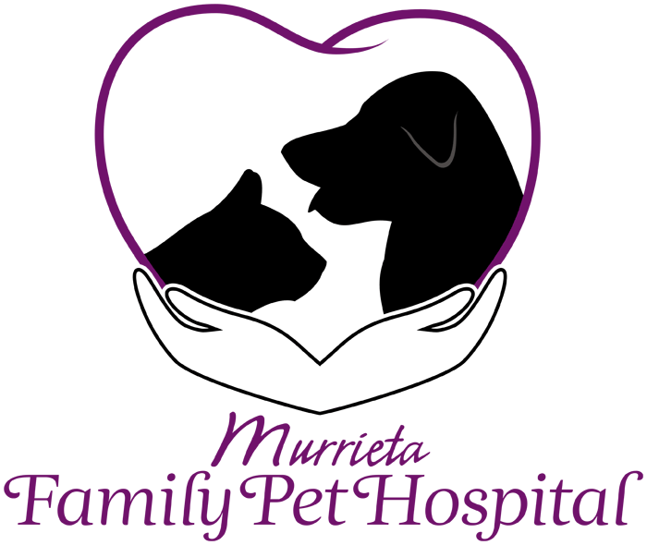

Alternative Therapies Consent Form
Owner’s/Agent’s Name: _____________________________
Address: ____________________________________________________________
Home Phone: _________________ Additional Phone:_____________________
Email Address: _____________________________
Pet’s Name: _______________________ Species: ___________ Breed: _______________
Color: ________________ Age: __________ Weight: ____________ Sex: __________
Presenting Condition:________________________________________________________
I hereby certify that I am the owner or an authorized agent of the owner for the above named pet and am over the age of 18.
I am aware that acupuncture can help many animals deal with painful situations and recover from various medical maladies but understand that this form of therapy will not help every patient. If the history and physical examination leads to the conclusion that acupuncture is not appropriate for my pet, I understand that the attending doctor will discuss other diagnostic and or treatment options. Most conditions were acupuncture is likely to help require a minimum of 8 initial weekly sessions. Thereafter, treatments may be continued over time for maintenance of my pet's health. If there is no response after 8 treatments, then acupuncture will not benefit your pet for the current problem. If my pet is not responding as expected and could benefit from other forms of traditional or alternative medicine, I am aware that the attending doctor may offer other forms of treatment or refer me back to my regular veterinarian, to a board-certified specialist or to a different alternative medical provider.
(Owner's initials) ________
I have been informed that for lameness and arthritic conditions, it is recommended that my regular veterinarian should already have exposed and processed radiographs of the affected area(s) and supplied copies to this practice. If this has not been or the films are not sufficient for the attending doctor to rule in or rule out various causes of my pet's condition, my attending veterinarian will discuss the need for additional images to be taken at my regular veterinarian. This is essential to help rule out problems such as cancer of the bone or infection that are unlikely to respond to acupuncture treatment. I am also aware that an MRI is the gold standard diagnostic test to determine neoplasia versus an intervertebral disc that is causing neurologic symptoms in my pet. If my pet is likely suspected to have intervertebral disc disease an MRI would accurately detect where the lesion or lesions are located. I understand that the more information that the attending doctor is given about my pet's current medical condition the better outcome in the treatment for my pet. (Owner's initials) _______
I understand that my pet's treatment may consist of the following therapies:
- Acupuncture with needles only: the insertion of a sterile acupuncture needle in specific areas that have high electrical conductance and low electrical resistance.
- Needles with electrical stimulation: a form of acupuncture in which pairs of acupuncture needles are attached to a device that generates continuous electric pulses between them. This treatment is not recommended for patients with a history of seizures due to the electrical stimulation may lower their threshold for seizures activity.
- Aqua-puncture: a form of an acupuncture that uses liquid such as vitamin b-12 or saline, inserted under the skin at various acupuncture points causing stimulation to the point.
- Moxibustion: burning of an herbal substance over the needle.
- Herbal formulas: use of herbal remedies for various medical conditions that may be used in conjunction with acupuncture.
- Laser Therapy: the use of specific wavelengths of light (red and near-infrared) to stimulate the body's natural ability to heal. The effects of laser energy include improved healing time, pain reduction, increased circulation and decreased swelling.
- Chiropractic Care: manipulation of the spine, bones and joints within the skeletal system using accepted chiropractic techniques. To correct many vertebral subluxations as well as other subluxations throughout the skeletal system it requires initial treatments of once to twice a week depending on the subluxations for 4 weeks of therapy and then the patient is re-evaluated for continued therapy.
- Essential Oils: any of a large class of volatile odoriferous oils of vegetable origin that give plants their characteristic odors and often other properties, that are obtained from various parts of the plants (as flowers, leaves, or bark) by steam distillation, expression, or extraction, that are usually mixtures of compounds (as aldehydes or esters), and that are used often in the form of essences in perfumes, flavorings, and pharmaceutical preparations—called also ethereal oil, volatile oil.

I have been advised that if additional diagnostic tests, procedures, or more aggressive care is recommended for my pet that I will be referred to my primary care veterinarian, an emergency hospital, or a specialty care hospital. I also understand and recognize that acupuncture, chiropractic care, herbal medicine, essential oils, and laser therapy are considered forms of complementary and alternative veterinary medicine and that I have been informed of the conventional treatments available and their probable ability to cure. I am aware that the practice of veterinary medicine is not an exact science, and thus no guarantee for successful treatment has been made. I have been encouraged to discuss any questions I may have and have them answered to my satisfaction.
I hereby give Murrieta Family Pet Hospital and any authorized agents, staff, or representatives full and complete authority to examine, prescribe for, or treat the above described pet. I agree to hold these parties harmless (not liable) for the absence of response to treatment or any direct, indirect or consequential damages or ill effects experienced by my pet resulting from such care. I assume full responsibility for the actions of the animal described above and all charges incurred in its care. I also understand that all professional fees are due at the time services are rendered.
I have carefully read and fully understand the above stated provisions.
Owner/Authorized Agent: _______________________________________
Date: _________________________________

